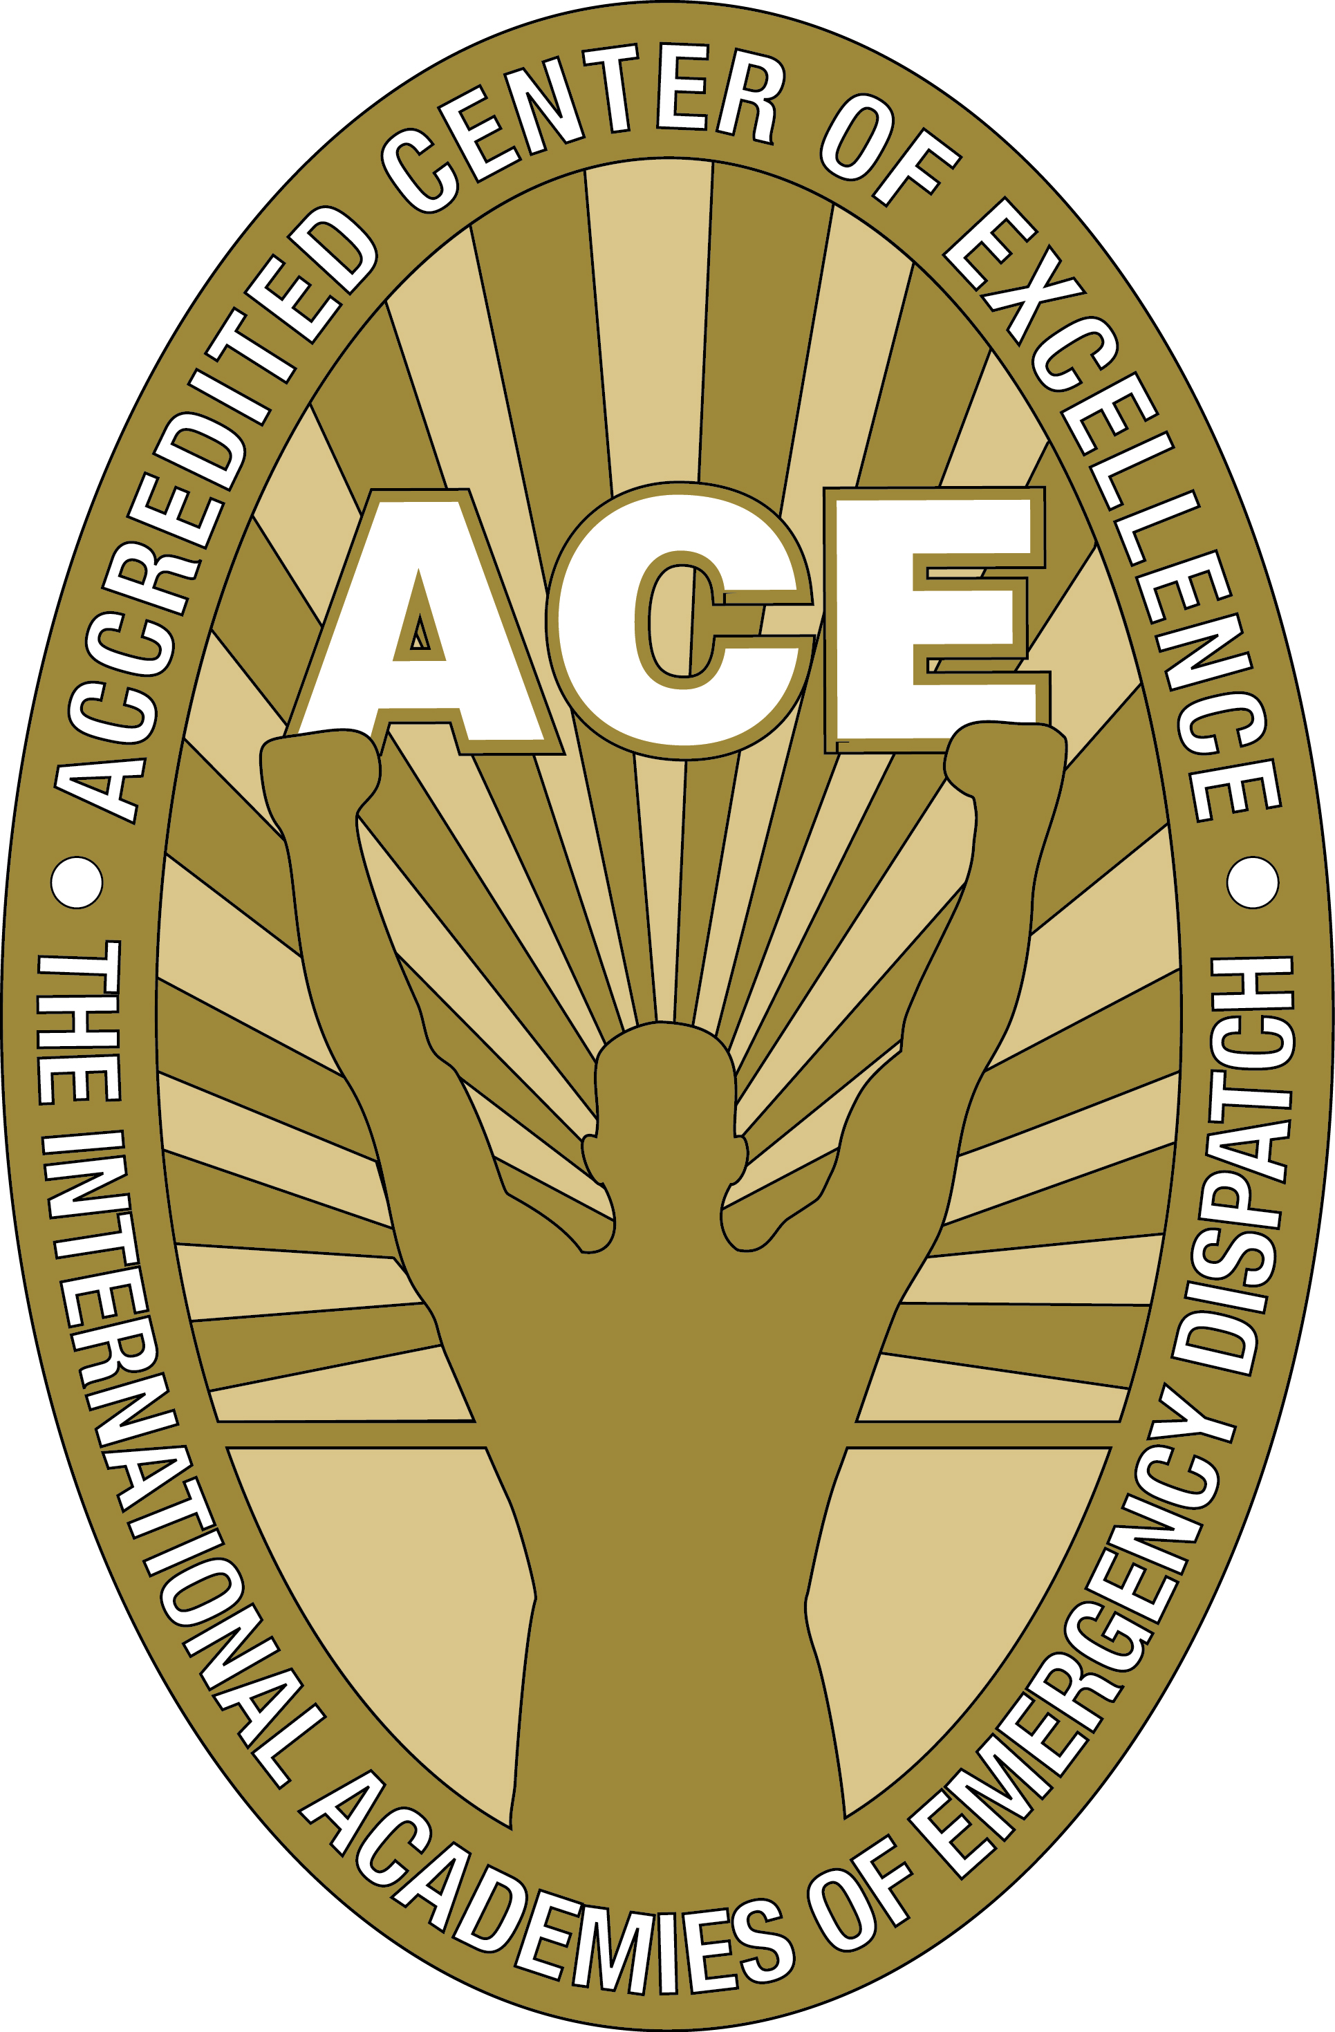
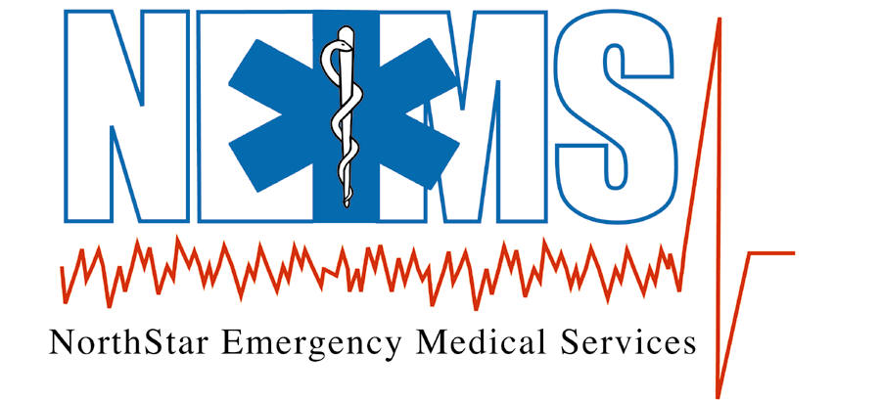

Date | NEMS Medical Minutes Topics
October 11, 2018 | Ketamin
October 18, 2018 | Backboard Usage
October 25, 2018 | Permissive Hyertension
November 1, 2018 | Traumatic Brain Injury
November 16, 2018 | Death in the Field
December 3, 2018 | Versed
December 12, 2018 | The Vial of Life
January 4, 2019 | Airway Control
January 17, 2019 | Therapeutic Hypotension
February 2, 2019 | Preventing Hypoxia During Intubation
February 17, 2019 | Cardiac Arrest in the Trauma Patient
March 11, 2019 | Critical Care Transport
April 4, 2019 | Glucagon
April 11, 2019 | Crush Injuries
May 2, 2019 | Health Professional on the Scene
May 31, 2019 | Trauma in the Geriatric Patient
June 21, 2019 | Hypertensive Emergencies
August 20, 2019 | Lightening Injuries
September 6, 2019 | Cardiac Arrest in the Renal Patient

